# **Employee Tracking System Project**

Contents

**Employee Tracking System Project** 1

**Database Design and Schema** 2

**Data base diagram** 3

**Database Sample data (5 records)** 4

EmployeesTbl 4

EmpHoursTbl 4

**Store Procedures** 4

**OOAD** 8

Presentation Tier 8

Logic Tier 9

Data Access 10

Class Flow Diagram 11

Design 18

Forms 18

**Demonstration** 22

Add new employee 22

Add employee working date and hours 23

Update employee by name 24

Update employee by ID or Email 26

Report 29

Delete employee 30

## **Database Design and Schema**

Picture Here

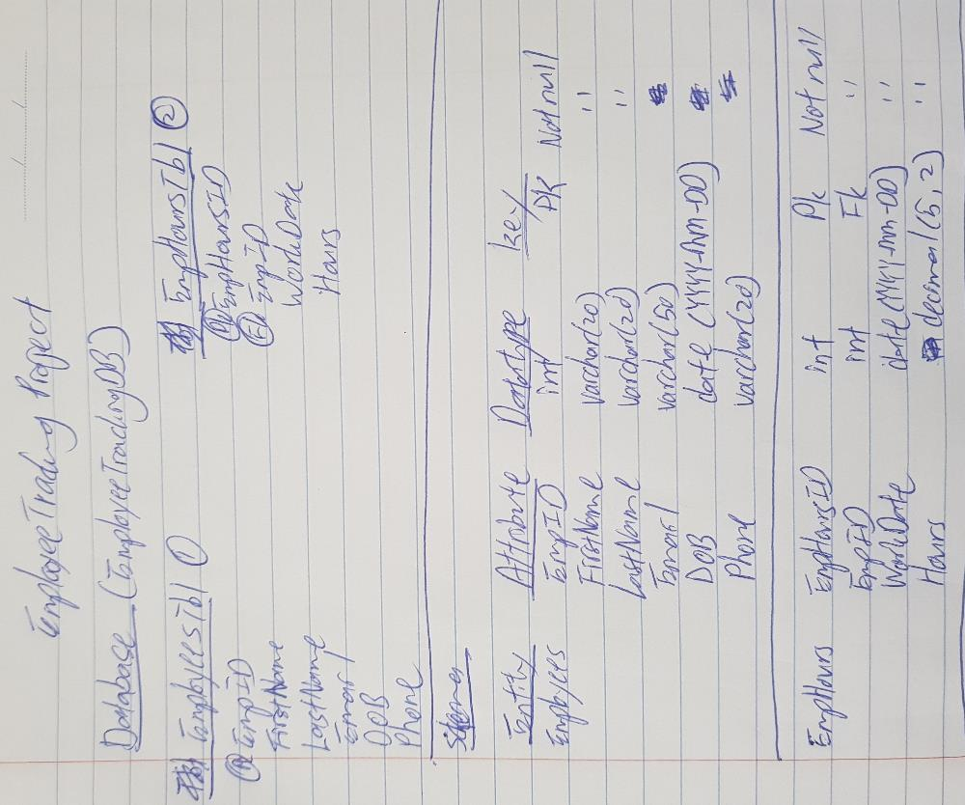

## **Data base diagram**

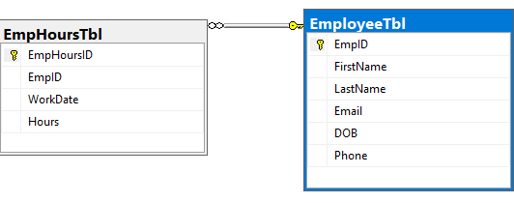

## **Database Sample data (5 records)**

### EmployeesTbl

|  |  |  |  |  |  |
| --- | --- | --- | --- | --- | --- |
| EmpID | FirstName | Lastname | Email | DOB | Phone |
| 1 | Sample1 | Last1 | [123@gmail.com](mailto:123@gmail.com) | 01/01/10 | 123456 |
| 2 | Sample2 | Last2 | [456@mail.com](mailto:456@mail.com) | 02/02/10 | 234567 |
| 3 | Sample3 | Last3 | [789@gmail.com](mailto:789@gmail.com) | 03/03/10 | 2134565 |
| 4 | Sample4 | Last4 | [abc@gmail.com](mailto:abc@gmail.com) | 04/04/10 | 234566 |
| 5 | Sample5 | Last5 | efg@gmail.com | 05/05/10 | 1234555 |

### EmpHoursTbl

|  |  |  |  |
| --- | --- | --- | --- |
| EmpHoursID | EmpID | WorkDate | WorkHours |
| 1 | 1 | 16/10/2018 | 8 |
| 2 | 2 | 16/10/2018 | 8 |
| 3 | 3 | 16/10/2018 | 8 |
| 4 | 4 | 16/10/2018 | 8 |
| 5 | 5 | 16/10/2018 | 8 |

## **Store Procedures**

1. EmpHoursTbl
2. EmployeeTbl

Command

-- Author: Alex Huk Kok Lung

-- Create date: 16/10/2018

-- Description:

1. Insert Employee

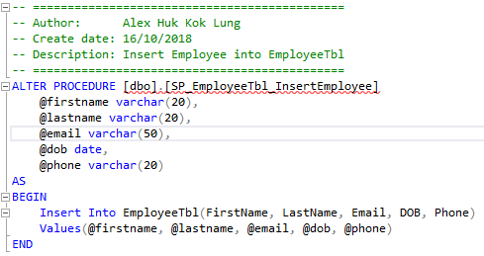

1. Update Employee

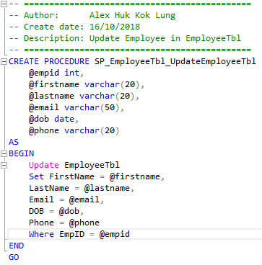

1. Insert hour

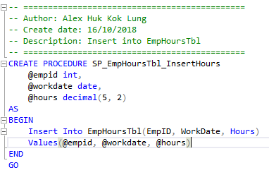

1. Select Employee By ID

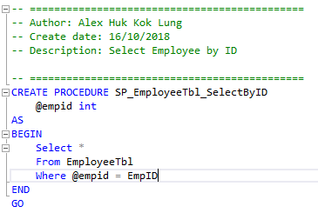

1. Select Employee by Email

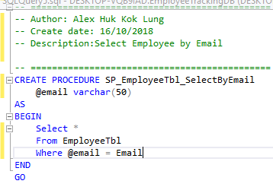

1. Select all Employee

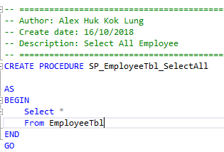

1. Select Work date and hours by EmpID

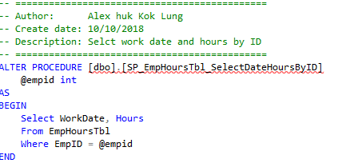

1. Delete from EmployeeTbl and EmpHoursTbl by EmpID

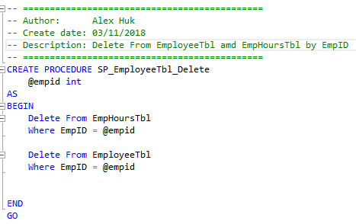

1. Sum Total Worked hours from EmpHoursTbl

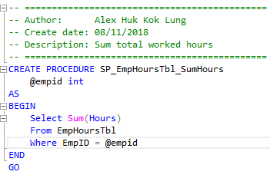

## **OOAD**

### Presentation Tier

Show Employee Report

Add Date and Hours

Add Employee

Home

Contact

Report

Manage

Add

MainForm

Update and Delete by ID or Email

Update and Delete By Name

### Logic Tier

Manager

EmployeeManager

Add()

ShowEmployee()

Edit()

Remove()

SearchByEmail()

SearchByID()

EnumResult

Result<T>

Result

Add()

WorkHoursManager

DisplayByID()

DisplayHours()

### Data Access

Dao

SumHours()

SelectDateHoursByID()

DeleteAll()

UpdateEmployee()

SelectByEmail()

SelectByID()

SelectAll()

EmployeweDao

Connection Helper

InsertHours()

WorkHoursDao

InsertEmployee()

CreateConnection()

### Class Flow Diagram

#### Add New Employee

Manager.Add()

"Error, please double check the detail and try again."

End

End

End

"Error occur in Manager/Add " + EX.Message

"New employee Added"

SP_EmployeeTbl_InsertEmployee

ConnectionHelper.CreateConnection()

Dao.InsertEmployee()

#### Add Date and Hours

End

"Work date and hour added."

SP_EmpHoursTbl_SelectDateHoursByID

"Error occur in WorkHoursManager/Add " + EX.Message

Dao.InsertHours()

End

Input

Display in TextBox

S

Display in List Box

SP_EmployeeTbl_SelectAll

End

"Error occur in Manager/FindEmployees, " + EX.Message

End

"Error, try again."

Dao.SelectAll()

manager.ShowEmployees()

#### Update Employee By Name

"New detail added."

End

End

End

End

SP_EmployeeTbl_UpdateEmployeeTbl

Dao. UpdateEmployee ()

"Error occur in Manager/Edit " + ex.Message

Input

Display in TextBox

S

Display in List Box

SP_EmployeeTbl_SelectAll

Dao.SelectAll()

"Error occur in Manager/FindEmployees, " + EX.Message

"Error, try again."

manager.ShowEmployees()

#### Delete Employee

"Are you sure want to delete this employee?"

NO

YES

End

"Delete success!"

SP_EmployeeTbl_Delete

"Error occur in Manager/Delete "

End

Dao.DeleteAll ()

End

"Error, try again later"

manager.Remove()

End

#### Update by ID and Email

"Error occur in Manager/Edit " + ex.Message

SP_EmployeeTbl_SelectByID/Email

Display Detail

Enter Detail

Dao. UpdateEmployee ()

SP_EmployeeTbl_UpdateEmployeeTbl

"New detail added."

End

End

End

"Error occur in Manager/SearchByID/Email"

Dao.SelectByID/Email()

End

"Error, try again."

manager.SearchByID/Email()

UpdateByID Form

#### Report

End

"Error, try again."

SP_EmpHoursTbl_SelectDateHoursByID

Display in Label

End

"Error occur in WorkHoursManager/DisplayByID" + EX.Message

Dao.SelectDateHoursByID()

manager.DisplayByID()

Select

S

manager.ShowEmployees()

"Error, try again."

Dao.SelectAll()

"Error occur in Manager/FindEmployees, " + EX.Message

SP_EmployeeTbl_SelectAll

Display in List Box

Display in Label

End

End

Employee Report Form

End

Display Total Hours

SP_EmpHoursTbl_SumHours

End

"Error occur in WorkHoursManager/DisplayHours "

Dao.SumHours()

"Error"

End

manager.DisplayHours()

### Design

Text:

1. Title: Microsoft Sans Serif, Bold, 10
2. Label: Microsoft Sans Serif, Regular, 10

Button:

1. Text: Microsoft Sans Serif, Bold, 14
2. Size: 145, 43
3. Back Colour: ActiveCaption

From:

1. FormBorderStyle: FixedSingle
2. StartPosition: CenterScreen
3. MaximizeBox: False
4. MinimizeBox: False
5. Size: 519, 400

### Forms

1. Main Form

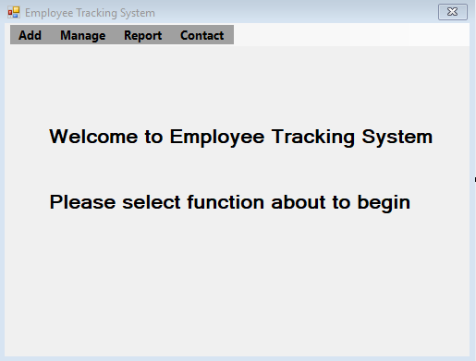

1. Add Employee Form

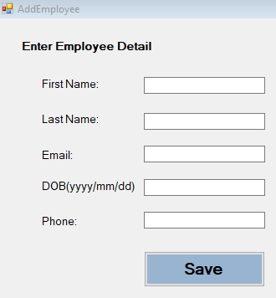

1. Add Work and Hours Form

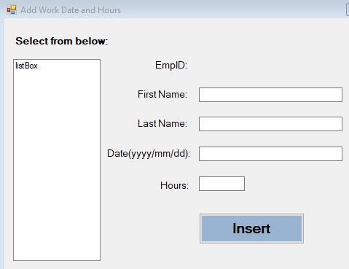

1. UpdateDelete Form

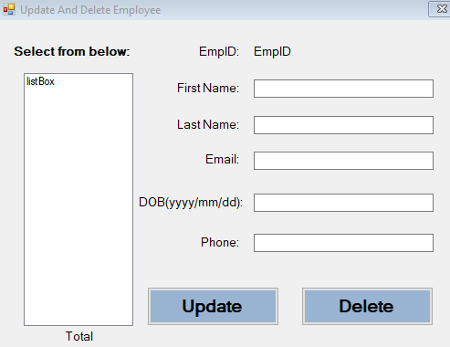

1. UpdateByID Form

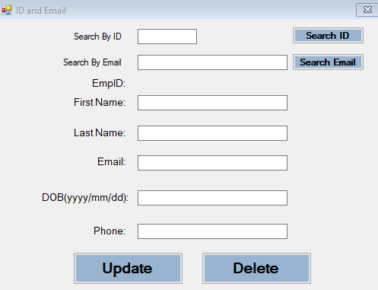

1. Report Form

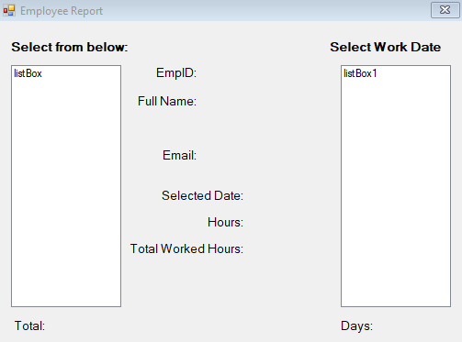

1. Contact Form

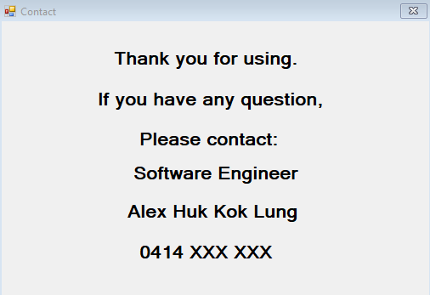

## **Demonstration**

### Add new employee

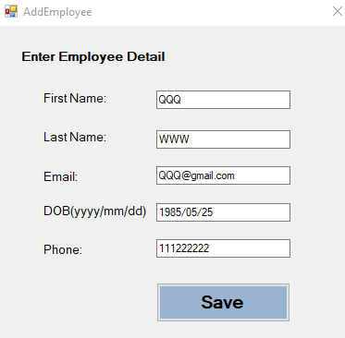

Message

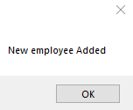

Database

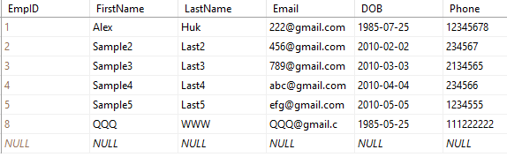

### Add employee working date and hours

Select

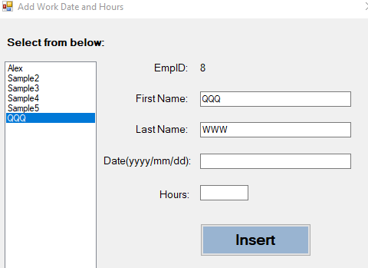

Enter detail

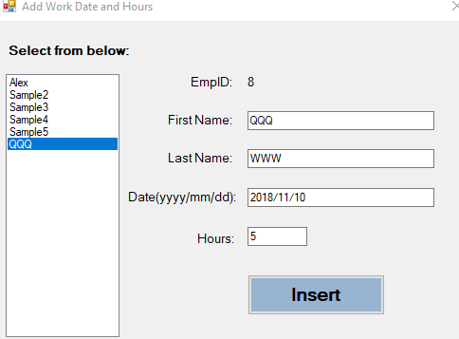

Message

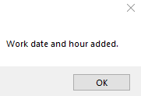

Data base

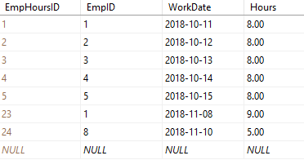

### Update employee by name

Select

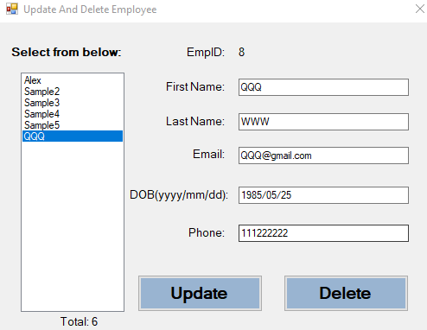

Change detail

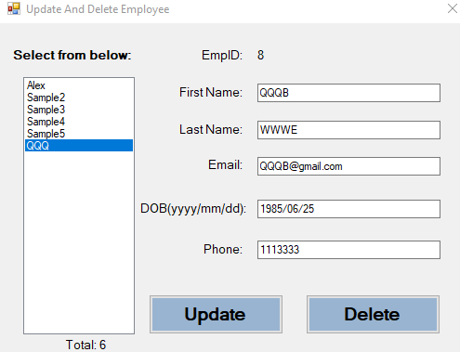

Message

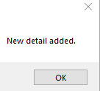

Data base



### Update employee by ID or Email

Enter employee ID

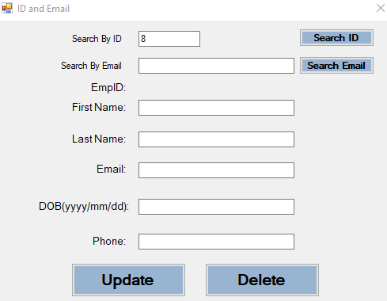

After click “Search ID”

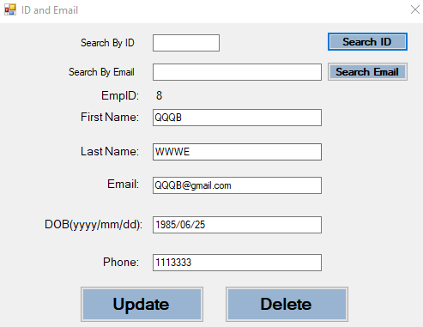

Change detail

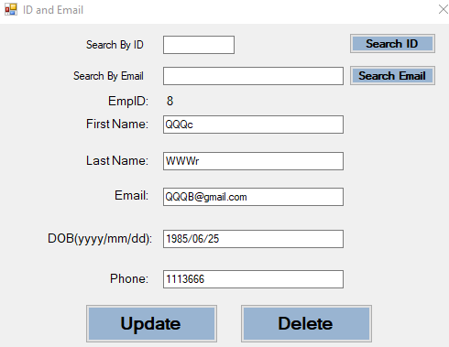

Message

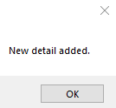

Enter email

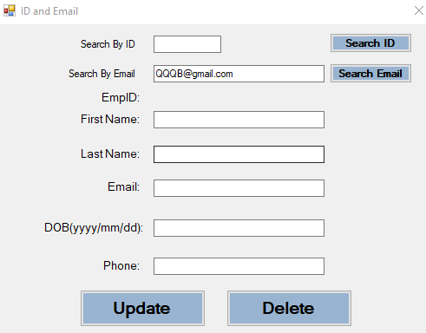

After click “Search Email”

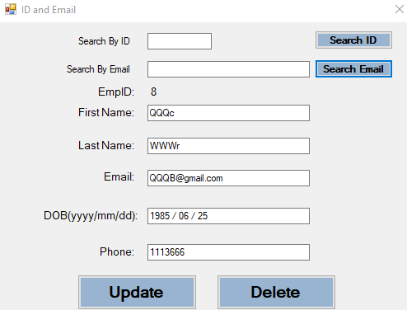

Enter detail

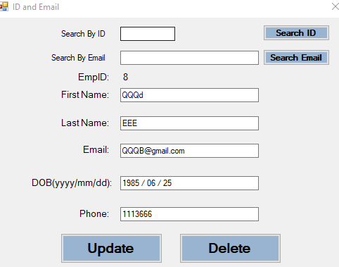

Message

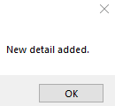

Data base

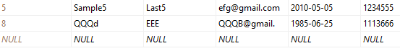

### Report

Select employee name and work date

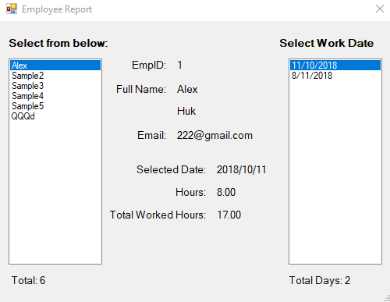

Select work date

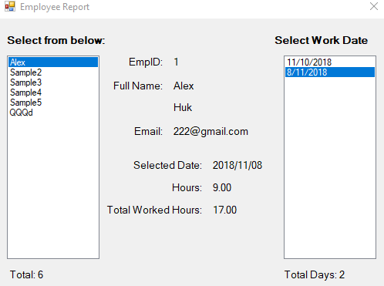

### Delete employee

Select employee name

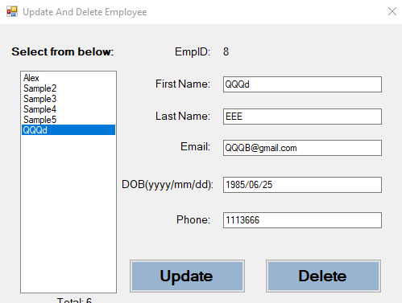

Message when click “Delete”

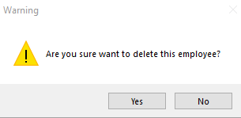

If “No”, nothing happen

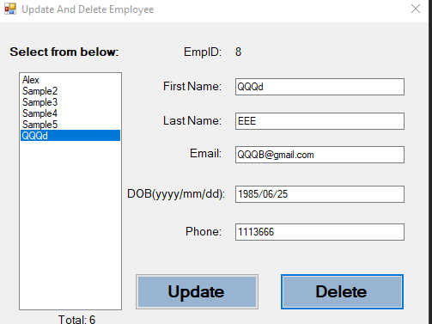

If “Yes”

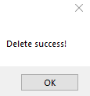

All record in both EmployeeTbl and EmpHoursTbl will be delete

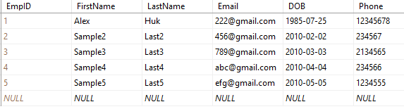

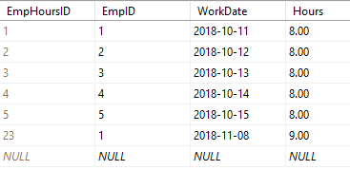

If ID not found

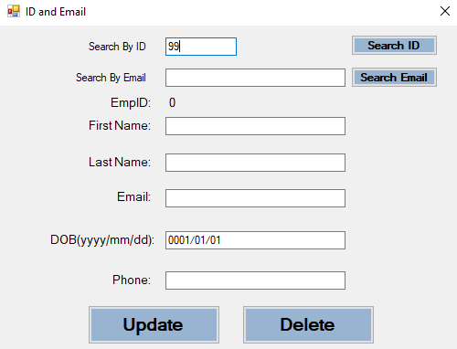

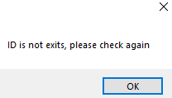

If ID is “0” or nothing

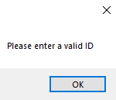

If email is nothing

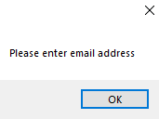

If email is not valid

